**RECEIVE VENDOR TAGS FOR RAW GOODS**

The Load Tag File for Raw Materials has a database field to house the bar code number provided by the board vendor which is represented as a bar coded tag number.   
Sharp Shooter RM button called Scan Vendor Tags.

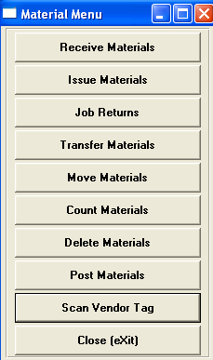

Click the Scan Vendor Tag button to scan the vendor supplied Bar Code Number.

If the Number has the proper format, all the information will transfer directly to the Screen including the Purchase Order Number, PO Line Number, Quantity Received and the Tag Number.

The Vendor RM Bar Code will equal PO#, PO Line#, Qty and Tag Number.

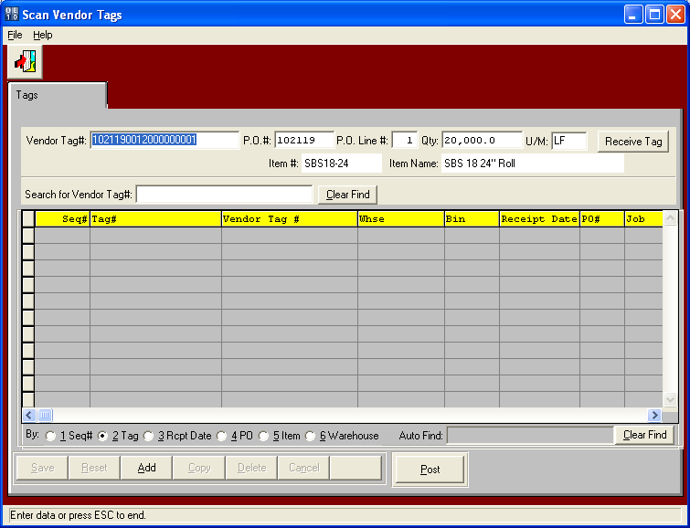

When the Vendor Tag Number 1021190012000000001 is scanned, this transfers to the PO#, PO Line# and Qty Fields. The Unit of Measure imports from the raw materials consumption unit of measure.

The RM Bar Code Tag format will be 999999 999 99999 99999 without any spaces.

The first 6 digits represent the ASI PO#.

The next 3 digits represent the ASI PO Line#.

The last 5 digits represent the quantity on the roll or pallet.

The last 5 digits represent the unique tag number.

In this example, 102119 represents the purchase order number. The 001 represents the line number of the purchase order, the 20000 represents the lineal feet on the roll and 00001 is the unique tag number.

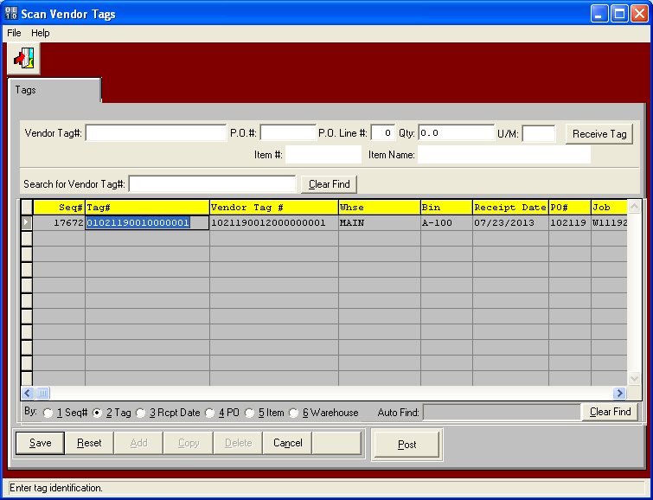

After Scanning the Vendor Tag, click RECEIVE TAG button and the data is loaded to the screen.  
Notice that both a new ASI tag number and vendor tag# are stored in the raw material tag file.  
Please note, N-K-1 SSPostVendorTags will eliminate this step as well as the step to post raw materials M-U-6. therefore, scanning a vendor tags will immediately result in on hand materials.

Scanning Vendor Tags works like the existing M-U-8 program when creating pallet tags. This will create the load tag in the raw materials loadtag file, which will download to RM tags depending on the item type. This will also download the PO#, Job#, item code, S/B code and same data loaded via the M-U-8 load tag creation. Each scanned vendor tag will create a new tag# in the Load Tag Raw Materials File with the quantity per tag then transfer the data to the SS Scan Vendor Tag program as a new RM receipt. Please note, the TEXT file need not be created, just the loadtag file. PLEASE NOTE, when scanning the tag for ISSUES or COUNTS, the vendor tag must find the ASI Tag number.